Multi Events Squad

This winter Athletics Northern Ireland will provide weekly development sessions for aspiring heptathletes and decathletes and their coaches.

Weekly technical development and education sessions overseen by Laura Kerr & Tom Reynolds will take place indoors at Ulster University Jordanstown. The sessions aim to bring together the combined eventers and their coaches to develop a community of practice and leverage available expertise in Northern Ireland. Laura and Tom will provide technical support for athletes and their coaches with access to the indoor track and gym at the university and will periodically invite other specialist coaches to focus on specific events.

Beginning in October sessions for athletes aged 14-19 years old (in the 2020 summer season) will take place on a Saturday at Ulster University, Jordanstown. Closer to the competitive season these sessions are likely to move outdoors to Mary Peters Track.

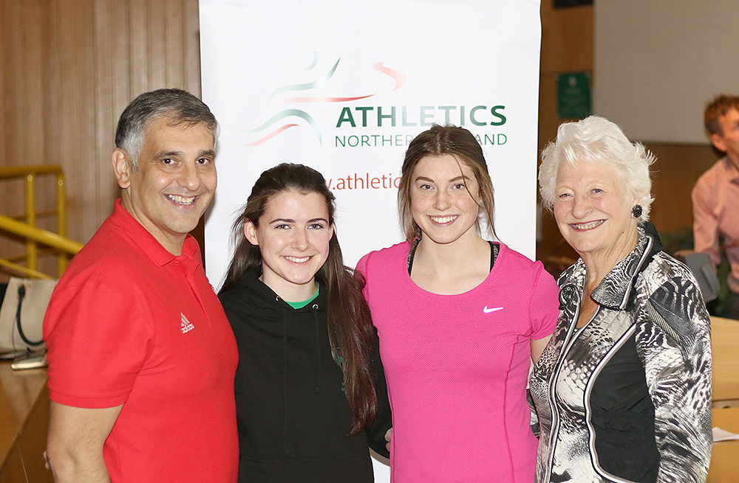

Northern Ireland has a rich history in Combined Events with Lady Mary Peters achieving Olympic Gold in 1972 and representation on Commonwealth Games teams from Brendan McConville (2006) Tom Reynolds (2010) Peter Glass (2014) and Kate O’Connor (2018.)

In recent years Athletics Northern Ireland have adopted a multi event approach for athletes up to 14 years of age. This allows early exposure to a range of technical events and paved the way for recent multi events successes for junior athletes such as Kate O’Connor-European U20 Silver Medalist and Anna McCauley who aged 18 represented Ireland at the European Combined Events Team Championships achieving a PB in Portugal. 2019 also saw Troy McConville set a new NI U20 Decathlon record of 6788.

To ensure progression of the talented young multi eventers in our sport and their coaches Athletics NI aim to provide opportunities for teenage athletes to learn and train together on a regular basis. Ultimately, we aim to have technically and physically well-prepared and robust young athletes progress to represent Northern Ireland at future Commonwealth Games and to create a community of practice for combined events coaches.

These sessions will provide an opportunity for multi eventers to hurdle and throw together in the indoor facilities at Jordanstown with specific expertise provided by Laura and Tom. The training emphasis will develop through the year keeping long term athlete development will in mind.

Periodically other specialist coaches will be invited to provide expertise to the group and Laura and Tom will use their experience to support coaches and athletes with planning and competition preparation. We appreciate athletes may travel from some distance away for these sessions and so each session will finish with a 1 hour supervised Strength and Conditioning session in the UUJ gym.

- Sessions will take place between 12.30 and 4.30pm at a cost of £8 per session with approximately 10 sessions in term 1 between the beginning of October and end of December. If this is a key session for any Academy athlete a fee waiver or discount will be organized.

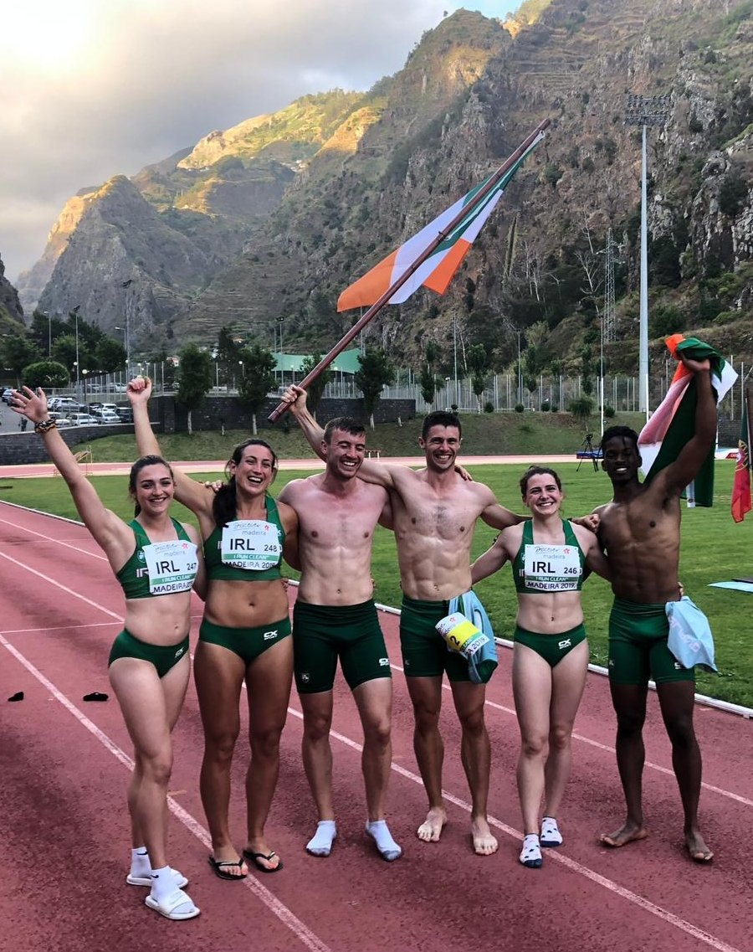

Application form

Please complete the following:

Name:
DOB:
School or University Year in September 2019:
Coach/es (please list all coaches that you work with)

Club:
Home Town:
Normal Training Location/s:
Please explain your Training experience and normal weekly training schedule;

Combined Events Scores
2017 PB: date;
2018 PB: date;
2019 PB: date;

Individual Event PBS

 | Event | Event | Event | Event | Event | Event | Event | Event | Event | Event
2018 PB:

2019 PB

After review of the applications there will be a selection process and successful applicants will be contacted with further information so that they can pay the registration fee online and provide emergency contact details etc.

Spaces will be limited to allow us to meet ideal coach to athlete ratios for technical events and applications will be assessed based on performance, potential and availability to engage. Coach-athlete pairs who would like to attend together to follow the training plan, upskill and benefit from working together in a group are welcome to apply and make note of this when completing the form above.

Applications may be typed or handwritten but must be either emailed to Tom@athleticsni.org or alternatively posted to arrive by 6pm 23rd September 2019 to:

Tom Reynolds

Athletics House,

Old coach Road,

Belfast

BT9 5PR

